Portrait d’une manifestante – Theodoros Lotis
program notes
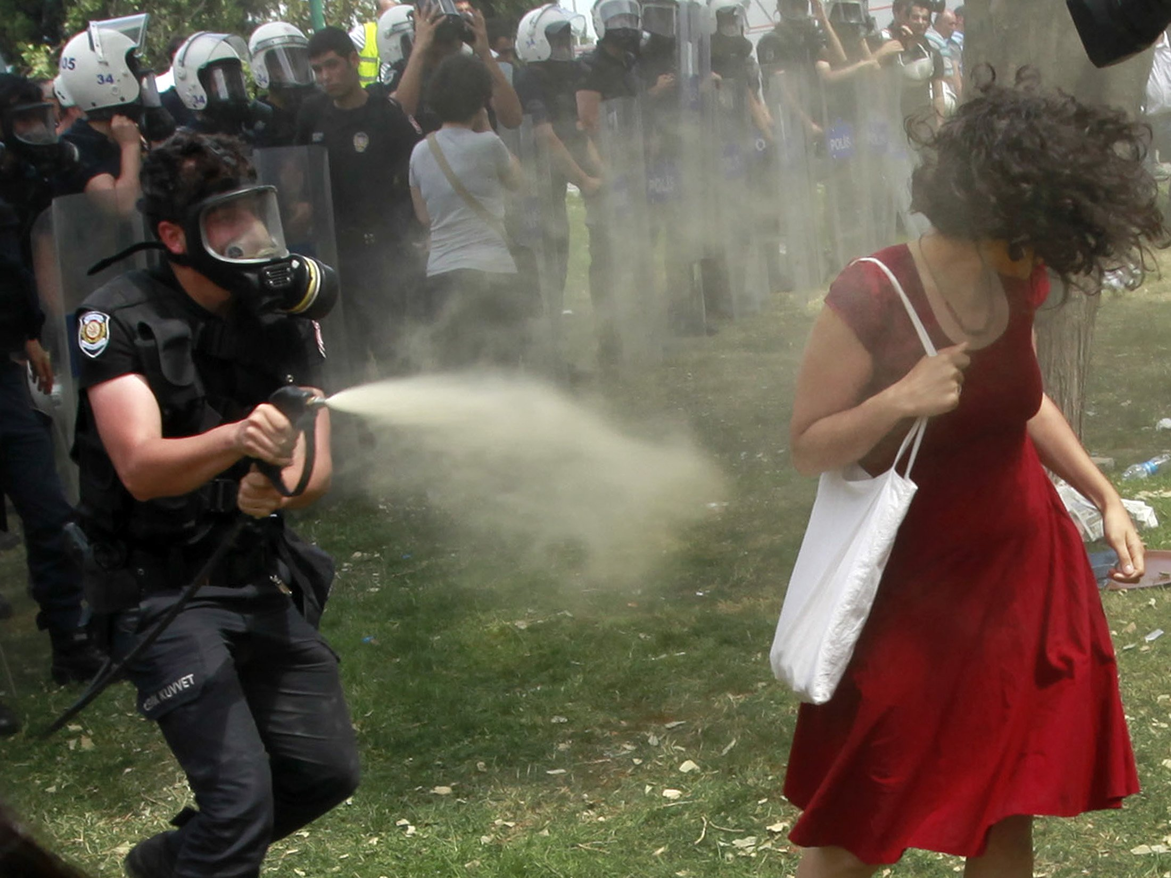

“Portrait of a Lady in Protest March” (8 channels) is a sonic portrait of a woman in red caught in the midst of a protest march. The work was commissioned by Musiques et Recherches and premiered at the Festival Espace du Son 2014. Many thanks to Esther Lamneck, Andreas Mniestris and Giorgos Stavridis for the clarinet, saxophone and percussion samples and to Terry Vakirtzoglou, Giorgos Mizithras and Olga Vassiou for their voices. The piece was finalist at the Metamorphoses 2016 competition in Brussels.

